% equation of motion of 2DOF open mechanism under PD control function dotq = open_mechanism_2DOF_PID_params (t, q, robot, thetad, Kp, Ki, Kd)
disp(num2str(t,"%8.6f"));
theta = q(1:2);
omega = q(3:4);
etha = q(5:6);
robot = robot.joint_angles(theta, omega);
[inertia_matrix, torque_vector] = robot.inertia_matrix_and_torque_vector;
dottheta = omega;
dotetha = theta - thetad;
tau = -Kp.*(theta - thetad) - Ki.*etha - Kd.*omega;
dotomega = inertia_matrix \ (torque_vector + tau);
dotq = [dottheta; dotomega; dotetha];
end
% PID control of 2DOF open mechanism
len = 2.5; radius = 0.06; density = 1;
link1 = Link_Cylinder ( len, radius, density );
link2 = Link_Cylinder ( len, radius, density );
base = [0; 0];
grav = [0; -9.8];
robot = Open_Mechanism_Two_DOF (link1, link2, base, grav);
thetad = [ pi; -pi/6 ];
Kp = [ 5.1; 5.1 ];
Kd = [ 1.75; 1.75 ];
Ki = [ 1.1; 1.1 ];
open_mechanism_2DOF_PID_ode = @(t,q) open_mechanism_2DOF_PID_params (t, q, robot, thetad, Kp, Ki, Kd);
interval = [ 0, 10 ];
thetainit = [ 0; 0 ]; omegainit = [ 0; 0 ]; ethainit = [ 0; 0];
qinit = [thetainit; omegainit; ethainit];
[time, q] = ode45(open_mechanism_2DOF_PID_ode, interval, qinit);
thetad1 = thetad(1)*ones(size(time));
thetad2 = thetad(2)*ones(size(time));
plot(time, q(:,1), 'r-', time, q(:,2), 'b-', ...
time, thetad1, 'r--', time, thetad2, 'b--');
title('PID angles');
xlabel('time');
ylabel('theta1 and theta2');
legend('theta1','theta2');
grid on;
saveas(gcf, 'open_mechanism_2DOF_PID_angles.png');
figure;
fprintf("pause: press any key\n");
pause;
clf;
sz = size(time);
for k=1:1:sz(1)
theta = q(k,1:2);
omega = q(k,3:4);
robot = robot.joint_angles (theta, omega);
robot.draw;
xlim([-6,6]);
ylim([ -4,6]);
pbaspect([2 1 1]);
grid on;
pause(0.01);
end
fprintf("pause: press any key\n");
pause;
clf;
hold on;
for k=1:1:sz(1)
theta = q(k,1:2);
omega = q(k,3:4);
robot = robot.joint_angles (theta, omega);
robot.draw;
xlim([-6,6]);
ylim([-4,6]);
pbaspect([2 1 1]);
grid on;
pause(0.01);
end
hold off;
saveas(gcf, 'open_mechanism_2DOF_PID_draw.png');
figure;
clf('reset');
ts = time(1);
te = time(end);
fr = 1;
clear M;
for t = ts:0.01:te
clf;
k = nearest_index(time, t);
theta = q(k,1:2);
omega = q(k,3:4);
robot = robot.joint_angles (theta, omega);
robot.draw;
xlim([-6,6]);
ylim([-4,6]);
pbaspect([2 1 1]);
title(['time ' num2str(t,"%3.2f")]);
grid on;
M(fr) = getframe(gcf);
fr = fr + 1;
end
M(fr) = getframe(gcf);
v = VideoWriter('open_mechanism_2DOF_PID_draw', 'MPEG-4');
open(v);
writeVideo(v, M);
close(v);
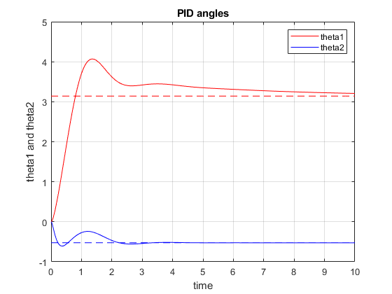
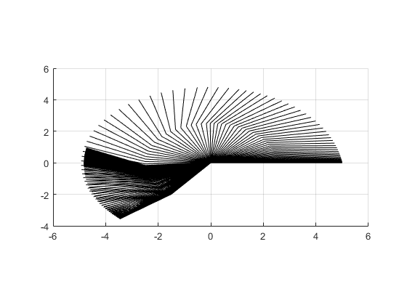
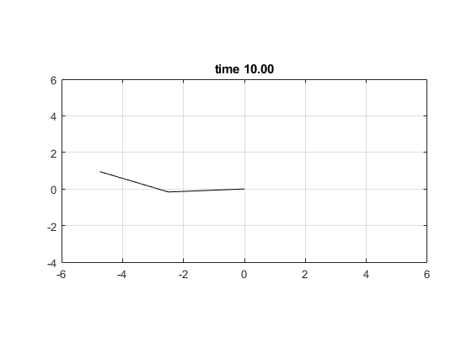
Published with MATLAB® R2022b

